🩺 Support for Alcohol & Substance Use

Referring into Change Grow Live (CGL) – Stockton

🔗 Simple Referral Options

🌐 Online Referrals
Patients can: - Self‑refer, or - Be referred by a professional
➡️ Referrals – Recovery Service – Stockton | Change Grow
www.changegrowlive.org/service/stockton-recovery/referrals#yourself

🚶 No Appointment Needed – Drop‑In Service
Patients can access support directly through our Drop‑In Service.

⏰ Opening Times
- Mon, Wed, Thu & Fri: 9:30am – 3:00pm
- Tuesday: 11:00am – 3:00pm

📍 Location
Change Grow Live
32–34 William Street
Stockton‑on‑Tees
TS18 1DN
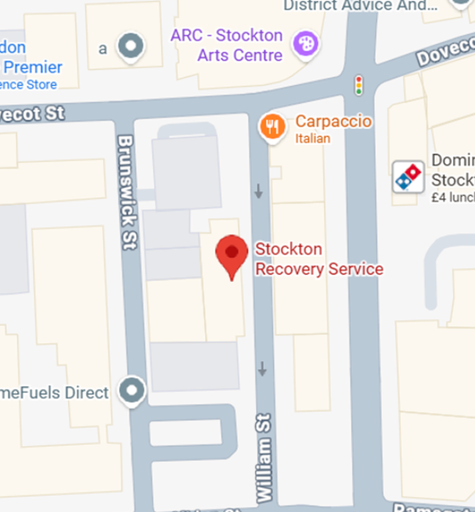

💚 Why Refer to CGL?
- Specialist alcohol & substance use support
- Accessible routes into treatment
- Confidential, person‑centred care

👉 Supporting recovery together in our community

